|  |
| --- |
|  |
| Website Design - Starter Implementation Handbook |
|  |
|  |
| http://televoxnet.west.com/Marketing/downloads/content/2013/TeleVox-Logo-HI-REZ.jpg |
|  |

Table of Contents

Getting Started 2

Office Preparation 2

TeleVox Implementation 2

Terms to Know 2

Web Starter Package Features 3

Responsive Design 3

Custom Pages 3

Online Patient Forms 3

Unlimited Site Training 3

Content Manager 3

Web Starter Layout Options 4

Neverland: http://startertest.televox.west.com/ 4

Features of this Framework: 4

Olympus: http://olympusbasetest.televox.west.com/ 5

Features of this Framework: 5

Atlantis: http://atlantisbasetest.televox.west.com/ 6

Features of this Framework: 6

Camelot: http://camelotbasetest.televox.west.com/....………………………………………..7

Features of this Framework: ………………………………………………………………………...7

TeleVox Implementation Process 8

Step 1: Site Consultation 8

Step 2: Site Development 8

Step 3: Site Review 8

Step 4: Site Launch 9

Support 9

Contact TeleVox 9

Introduction

Thank you for your recent TeleVox purchase! We are very excited to work with your practice and want to provide some information to help you and your staff prepare for the new system. This document is meant to serve as a guide throughout your implementation and provide information on what to expect and how you can help make your site launch as easy and stress-free as possible. Please take a moment to read the following information to gain a better understanding of how TeleVox can be most successful for you!

# Getting Started

## Office Preparation

* Begin by completing the online survey at: <https://www.televox.com/website/site-survey/> which will help us to develop content and collect images to make your website unique.
* Take some fun staff photos! Patients love seeing your office’s personality, and custom photos will help make your website look and feel more original.

## TeleVox Implementation

* For your TeleVox implementation, you will be assigned a dedicated Web OnBoarder who will work with you throughout the implementation process and can assist in any decisions that must be made for your site.
* The detailed implementation steps are defined in more detail later in this guide, but you can feel confident knowing that you will be working with a highly skilled team who will guide and assist at every turn!

## Terms to Know

* During your implementation, TeleVox will gather the requirements and vision you have for your site. To ensure optimal communication for these consultative calls, several of the important “terms to know” are described below:
  + Callout Box: an action item located on your homepage. It serves as a prompt for your patient to click, in order to learn more about a specific topic or take an action. Common callout box topics: Request an Appointment, Meet the Doctor, Contact Us, and Map & Directions.
  + Feature Box: an action item located on your homepage that allows content to be displayed. It serves as a way to go into a more detail about a product or service, and it also prompts the patient to click to learn more. Common feature box topics: Invisalign, Types of Braces, Cosmetic Dentistry, Botox, Sedation, Meet Our Doctors, etc.
  + Utility Navigation: a small area near the top header of your website that prominently displays pertinent contact information as well as social media icons that apply to your practice. Common utility navigation topics: phone number(s), address (es), Facebook icon, Twitter icon, Instagram icon, etc.
  + Widget: a small software application that is installed on your homepage to display information from a related third-party website. Common widgets: Facebook feed, Google Virtual Tour, scrolling testimonials, etc.

# Web Starter Package Features

## Responsive Design

* Desktop, mobile and tablet –optimized websites make sure patients can find you on the web from home or on the go and easily engage with your website from any device**!**

## Custom Pages

* TeleVox has a robust library of standard healthcare content for you to choose from, or if needed, custom content can be written for your site. For the package you have purchased, you are given up to fifteen (15) pages of custom written content.

## Online Patient Forms

* Use digital forms that your patients can complete on your websites. Patient forms are easy to create, and include drag and drop functionality that allows you to add, edit and remove fields!

## Unlimited Site Training

* We offer unlimited online training sessions that cover a variety of topics to help you learn the basics of your website…and then take it to the next level! You can even participate in an interactive Q&A session with one of our trainers!

## Content Manager

* Easily write, share and publish content for your site using the Content Manager, which includes access to specialty-specific images, text and multimedia!

# Web Starter Layout Options

## Neverland: <http://startertest.televox.west.com/>

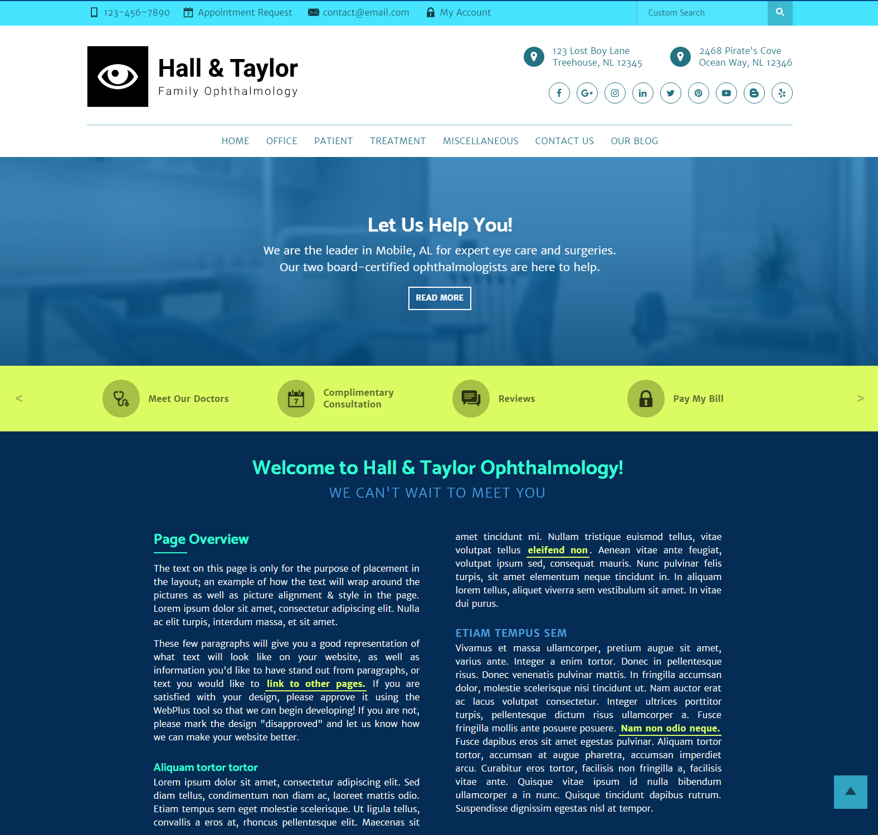

### Features of this Framework:

* Left-to-Right Menu Options and Center-Focused Menus and Content
* Left and Right side feature options on the homepage: <http://startertest.televox.west.com/miscellaneous/customization/homepage>
* 18 color palettes: <http://startertest.televox.west.com/miscellaneous/customization/predesigned-color-palettes>
* 13 font options: <http://startertest.televox.west.com/miscellaneous/customization/font-options>

## Olympus: <http://olympusbasetest.televox.west.com/>

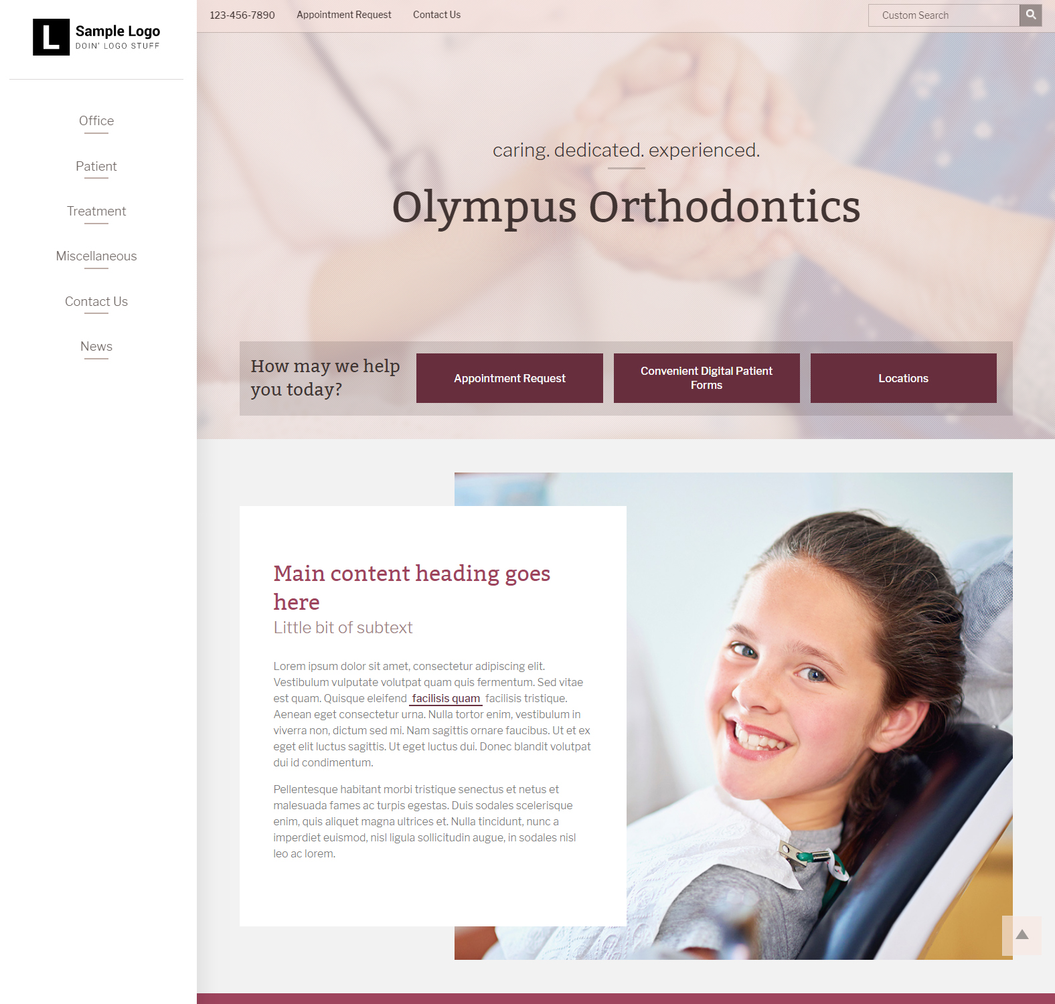

### Features of this Framework:

* Top-to-Bottom Menu Options
* Various feature, call out and other options on the homepage: <http://olympusbasetest.televox.west.com/miscellaneous/customization/homepage>
* 18 color palettes: <http://olympusbasetest.televox.west.com/miscellaneous/customization/predesigned-color-palettes>
* 13 font options: <http://olympusbasetest.televox.west.com/miscellaneous/customization/font-options>

## Atlantis: <http://atlantisbasetest.televox.west.com/>

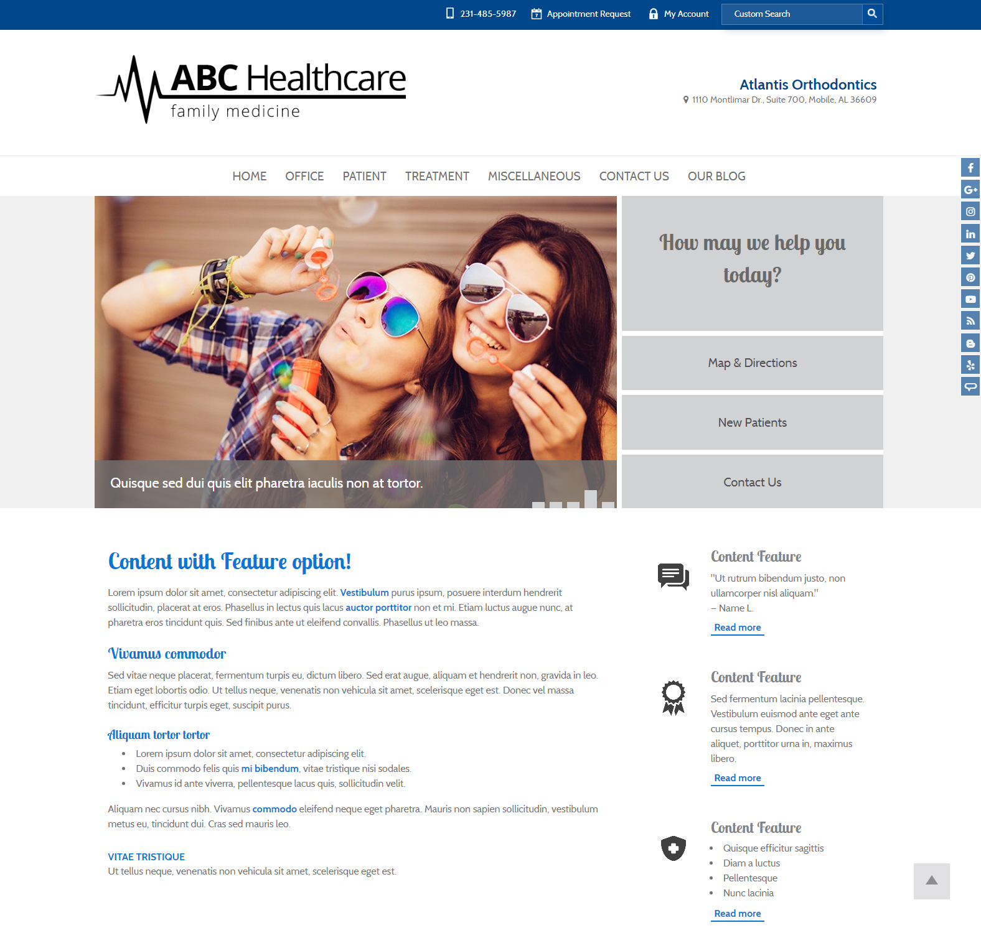

### Features of this Framework:

* Left-to-Right Menu Options
* Various feature, call out and other options on the homepage: <http://atlantisbasetest.televox.west.com/miscellaneous/customization/homepage>
* 18 color palettes: <http://atlantisbasetest.televox.west.com/miscellaneous/customization/predesigned-color-palettes>
* 13 font options: <http://atlantisbasetest.televox.west.com/miscellaneous/customization/font-options>

## Camelot: <http://camelotbasetest.televox.west.com/>

### C:\Users\crlundy\AppData\Local\Microsoft\Windows\Temporary Internet Files\Content.Outlook\CYYG0FHC\Camelot (003).JPG

### Features of this Framework:

* Left-to-Right Menu Options
* Various feature, call out and other options on the homepage: <http://camelotbasetest.televox.west.com/>
* 18 color palettes: <http://camelotbasetest.televox.west.com/miscellaneous/customization/predesigned-color-palettes>
* 13 font options: <http://camelotbasetest.televox.west.com/miscellaneous/customization/font-options>

# TeleVox Implementation Process

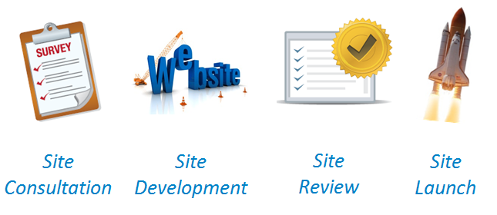

## **Step 1: Site Consultation**

* During the Site Consultation, your OnBoarder will gather basic information about your office, the doctor, and the team, as well as ask key questions about what makes your office unique. A decision-maker needs to be on this call, since questions about branding and content will be discussed. This step is vital in your implementation process as it initiates the foundation upon which we will build your entire online footprint! Mutual investment from both TeleVox and our clients is very important. Once the survey is completed, we will submit your site to development.

## **Step 2: Site Development**

* During Site Development, your TeleVox OnBoarder will confirm that all needed materials have been gathered. In the event that something is missing or additional information is needed, your OnBoarder will reach out to notify you. Once your site is submitted to development, TeleVox will construct the site graphics based on the feedback received during your site consultation. Simultaneously, our copywriter team will prepare the content to be placed in your new website. Once the development team has completed building your website, our quality assurance team will review the site for any errors. Upon quality assurance review and any errors corrected, your site will be moved forward to the Site Review phase.

## **Step 3: Site Review**

* During the Site Review, your TeleVox OnBoarder will provide a preview link that you can click to review your site design. Please note that although this will be the fully-developed website, it will not be on the live domain just yet. You will have 10 days to review the site and provide feedback on any changes we need to make to the content within the site. After the 10-day review period, we will move into the Site Launch phase.

## **Step 4: Site Launch**

* During Site Launch, TeleVox will activate your website on the live domain and submit it to online search engines. TeleVox will also provide you with the website login information to make any changes needed once your site is launched.

# Support

TeleVox wants to be sure your site is a success! As your website comes to life, we would encourage you to view our support site at <https://www.televox.com/website/support/>, which includes a number of resources including support documentation and opportunities to sign up for training!

# Contact TeleVox

Phone: 877-269-2904

Hours of Operation: Monday – Friday, 7:00 a.m. – 5:00 p.m. Central

Email: [televoxweb@west.com](mailto:televoxweb@west.com)